
User Manual

By

Zainab Hassan Al-Badi 2220002372
Hebah Ahmed Altheyab 2220001030
Doja Abdulmohsen Alnemer 2220002855
Zinab Mukhtar Alrashed 2220003194
Donia Abdullah Alfarhan 2220004173

Supervised by
Mrs. Albandary Mohammad Alamer

Committee Member Names
Dr. May Issa Aldossary
Mrs. Hina Gull

2026
DECLARATION

We hereby declare that this project report entitled Nekhlawi is a record of an original work done by us under the guidance of Supervisor Albandary Mohammad Alamer, Assistant Professor at College of CSIT, and that no part has been plagiarized without citations, which have been duly acknowledged. We also declare that it has not been previously or concurrently submitted for any other degree or award at any university or any other institutions. This project work is submitted in the partial fulfillment of the requirements for the degree of “Bachelor of Science in Computer Information Sciences” at Computer Information Sciences Department, College of Computer Sciences and Information Technology, Imam Abdulrahman Bin Faisal University.

Table of Content
1. Introduction 3
1.1. Purpose of This Document 3
1.2. Overview of the Nekhlawi Application 3
1.3. Target Users 3
1.4. Key Features 3
1.4.1. AI-Based Palm Disease Detection 3
1.4.2. Expert Consultation System 3
1.4.3. Mini Wiki Knowledge Base 3
1.4.4. User Profile Management 3
1.4.5. Appointment Scheduling 3
1.5. Copyright Statement 3
1.6. Version 3
1.7. Release Date 3
1.8. Prepared by 3
1.9. Supported Platforms 3
2. User Roles and Access Levels 4
2.1. Farmer (Standard User) 4
2.2. Expert User 4
2.3. Role-Based Permissions 4
3. Data Security and Privacy 4
3.1. User Authentication 4
3.2. Data Protection Measures 4
3.3. Secure Communication 4
3.4. Role-Based Data Access 4
3.5. User Privacy Considerations 4
4. Icons and Interface Elements 4
5. User Interfaces 4
5.1. Shared Interfaces 4
5.2. Farmer Interfaces 5
5.3. Expert Interfaces 5
6. How to 5
7. Frequently Asked Questions (FAQ) 5
8. Contact and Support 5

Table of Tables
Table 1: Icons and Interface Elements 7

Table of Figures
Figure 1: Welcom Pages 7
Figure 2: Role Selection Page 8
Figure 3: Terms and Conditions Page 9
Figure 4: Home Page 9
Figure 5: Account Page 10
Figure 6: Mini Wiki Page 10
Figure 7: Booking Expert Section Page 11
Figure 8: History Page 11

- Introduction
  - Purpose of This Document

  - Overview of the Nekhlawi Application
The Nekhlawi application is a mobile-based integrated solution that is intended to assist palm tree owners by availing easily accessible tools in order to detect diseases, identify pests and classify date varieties. The system is a smart helper that bridges the gap between the conventional farming knowledge and the current technological practices. It integrates machine learning, artificial intelligence, image processing and management of expert knowledge in a single platform.

  - Target Users
The Nekhlawi app targets two main user categories:
- The first is an experienced user or expert who has deep knowledge in palm tree and frequent interaction with agricultural technology how use the platform to provide paid consultations and offer treatment recommendation.
- The second is a typical palm owner with average experience and general knowledge of farming practices how use the platform to receive AI-based disease detection and treatments, and book consultations with agricultural experts.

  - Key Features
    - Account & Profile Management
Allows users to manages their accounts within the system. And create an account, log in, and manage their personal profiles. It ensures user identity verification and provides password recovery options.
    - AI-Based Diagnosis & Treatment Recommendation
Allows users to upload images of palm trees for diagnosis. The AI analyzes the image detecting diseases and provides detailed treatment recommendations.
    - Consultation Booking
Enables users to schedule consultations with palm experts, provides available time slots and booking confirmation.
    - Consultation Management & Scheduling:
Allows experts to manage their consultation workflow, set availability, approve or reschedule bookings, and organize their calendar.
    - Consultation Chat System
Enables real-time communication between users and experts, supports messaging, image sharing and voice notes.
    - Diagnosis & Consultation History Management
Provides users and experts with access to previous diagnoses and consultations.
    - Palm Care Knowledge Hub
Offers an educational library containing guides, articles, FAQs and preventive tips about palm care.

  - Copyright Statement
© 2026 Nekhlawi Project Team - Imam Abdulrahman Bin Faisal University
This document was prepared as part of the graduation project requirements for the Information Systems program.
All rights reserved.
No part of this document may be reproduced or distributed without permission from the authors or the university.

  - Version
1.0

  - Release Date

  - Prepared by
This project was prepared by students of Team 6 of the Information Systems Department, College of Computer Science and Information Technology, King Faisal University under the supervision of Mrs. Albandary Mohammad Alamer as part of the graduation project requirements.

  - Supported Platforms
The Nakhlawi app supports two main platforms
- Android
- IOS
with the possibility of future expansion to other platforms.

- Data Security and Privacy
  - User Authentication

  - Data Protection Measures

  - Secure Communication

  - Role-Based Data Access

  - User Privacy Considerations

- Icons and Interface Elements
This section gives a full description of screen Icons and their actions shown in the table below.
Table 1: Icons and Interface Elements
Object | Type | Action

- User Interfaces
  - Shared Interfaces
    - Welcome Pages

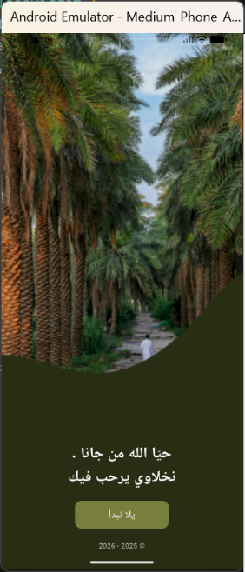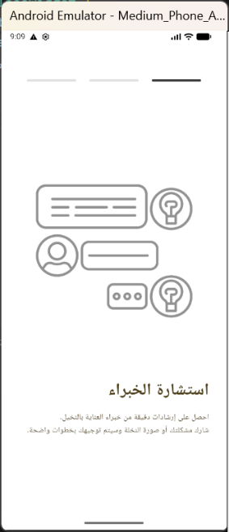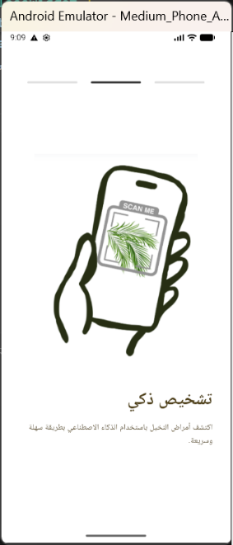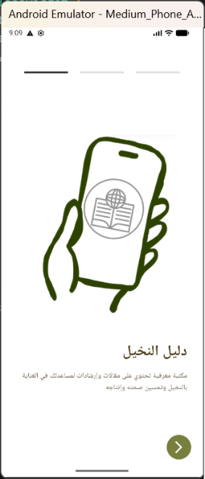
Figure 1: Welcom Pages

    - Sign up Page

    - Forget Password Page

    - Role Selection Page

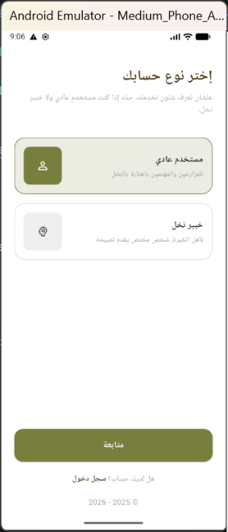
Figure 2: Role Selection Page

    - Sign in Page

    - Terms and Conditions Page

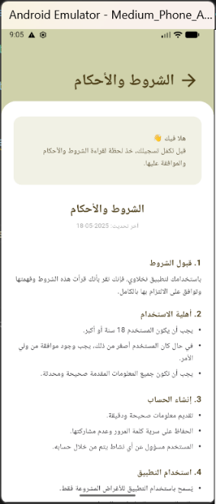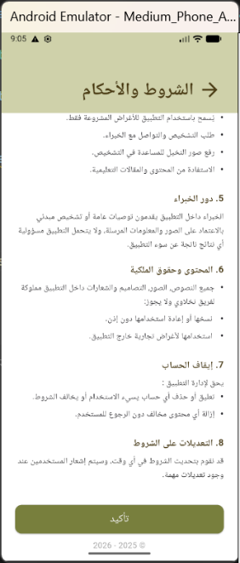
Figure 3: Terms and Conditions Page

  - Farmer Interfaces
    - Home Page

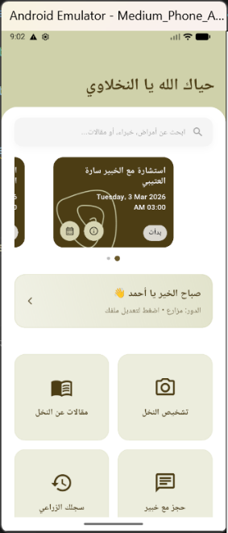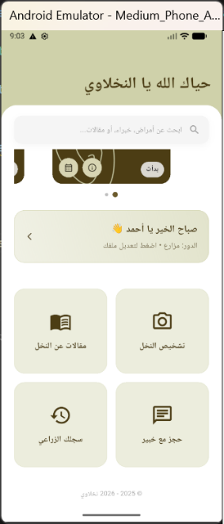
Figure 4: Home Page

    - Account Page

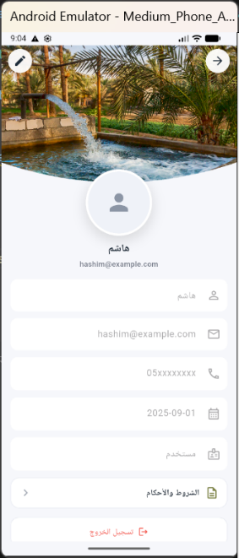
Figure 5: Account Page

    - Mini Wiki Page

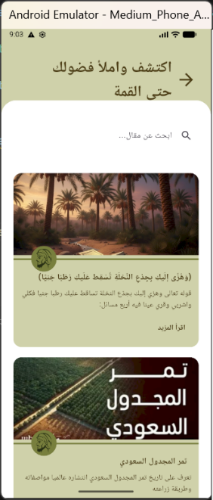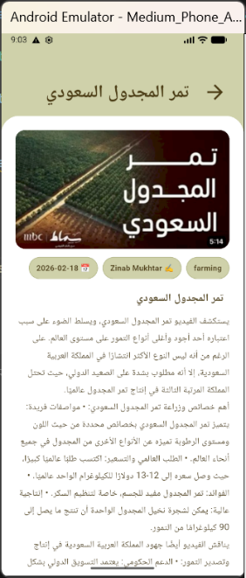
Figure 6: Mini Wiki Page

    - Booking Expert Section Page

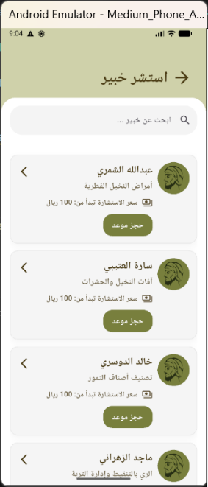
Figure 7: Booking Expert Section Page

    - History Page

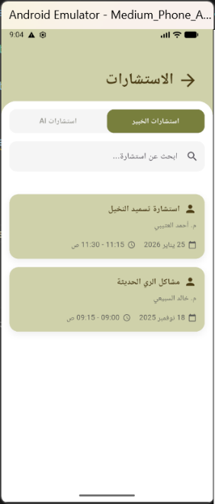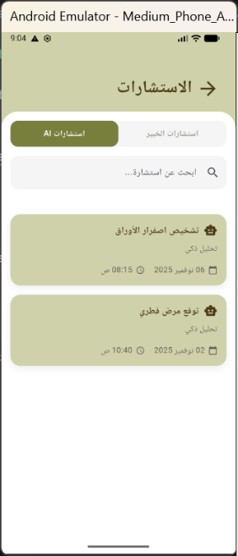
Figure 8: History Page

    - Expert Interfaces

- How to
  - Shared
    - How to Create an Account
- Open the Nekhlawi app
- Tap Sign Up
- Enter your name, email, and password
- Verify your email or phone number
- Your account will be created successfully
نحط صور بالخطوات

    - How to Log In
- Open the app
- Enter your email and password
- Tap Log In
نحط صور بالخطوات

    - How to Edit Your Profile
- Go to the Home Screen
- Tap Profile
- Tap Edit Profile
- Update your information
- Save changes

  - Farmers (Standard Users)
    - How to Scan a Palm Disease
- Go to the Home Screen
- Tap Scan Palm
- Take a photo or upload an image
- Wait for the AI analysis
- View the diagnosis result and recommendations
نحط صور بالخطوات

    - How to Book an Expert Session
- Go to the Home Screen
- Tap Scan Booking Experts Section
- Browse available experts
- Select an expert profile
- Tap Book Appointment
- Choose date and time
- Confirm booking
نحط صور بالخطوات

    - How to View the Mini Wiki
- Go to the Home Screen
- Tap Mini Wiki
- Browse Palm Care Articles
- Tap an article to read details

    - How to View Consultation History
- Go to the Home Screen
- Tap History
- View previous consultations and bookings

  - Experts

    - How to Manage Appointments

    - How to Respond to Consultations

- Frequently Asked Questions (FAQ)
Q: Do I need internet to use the app?
Q: How accurate is the disease detection?
Q: Who can see my uploaded images?
Q: How can I achieve the best diagnostic results?
Q: Can I cancel an appointment?

- Contact and Support
For any further questions, feedback, or technical issues you may contact the development team via the project email: nekhlawi.ksa@gmail.com.

